**Human Recurs :**

**Add (Employee- Teacher-Worker)**

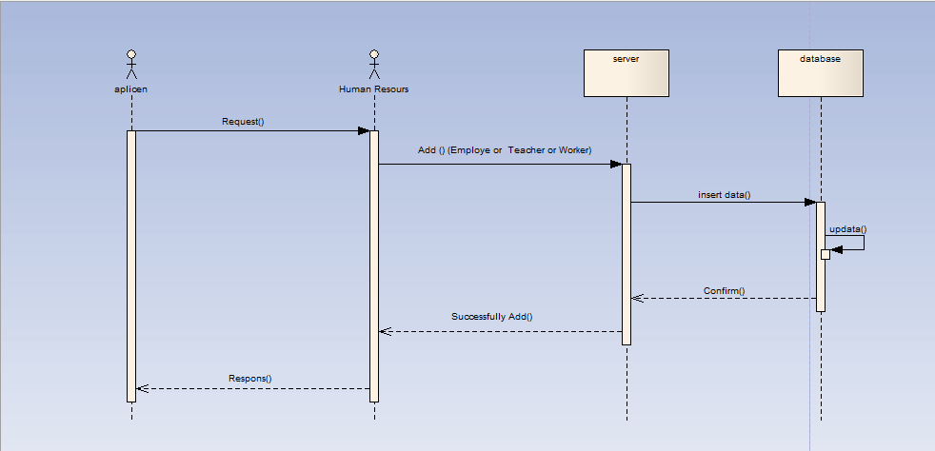

**Edit(Employee- Teacher-Worker):**

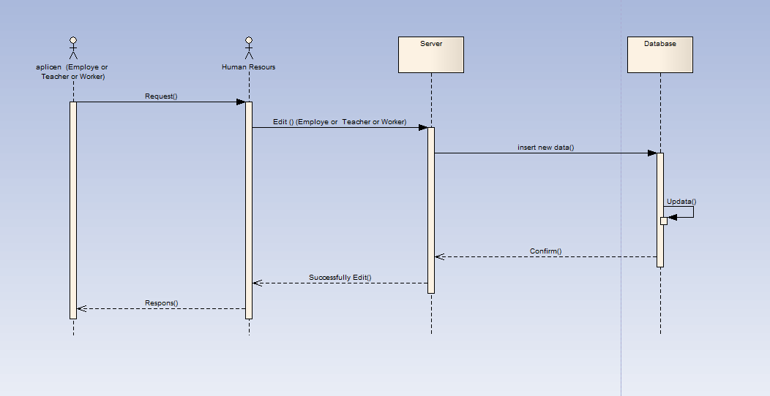

**Delete(Employee- Teacher-Worker):**

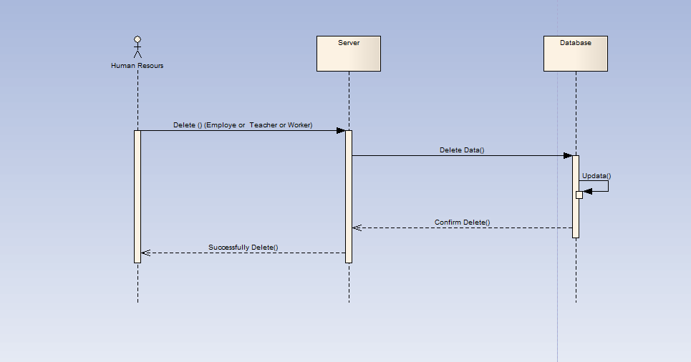

**Expenses & Musthqat :**

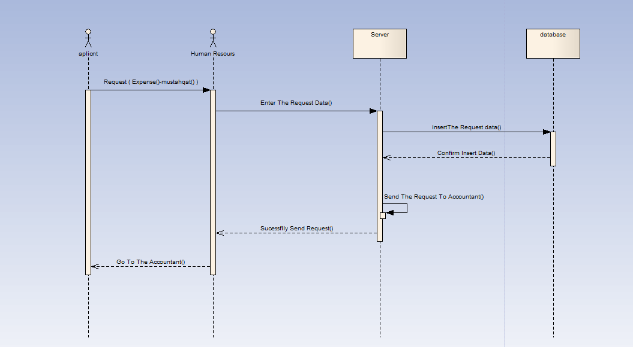

**Loans :**

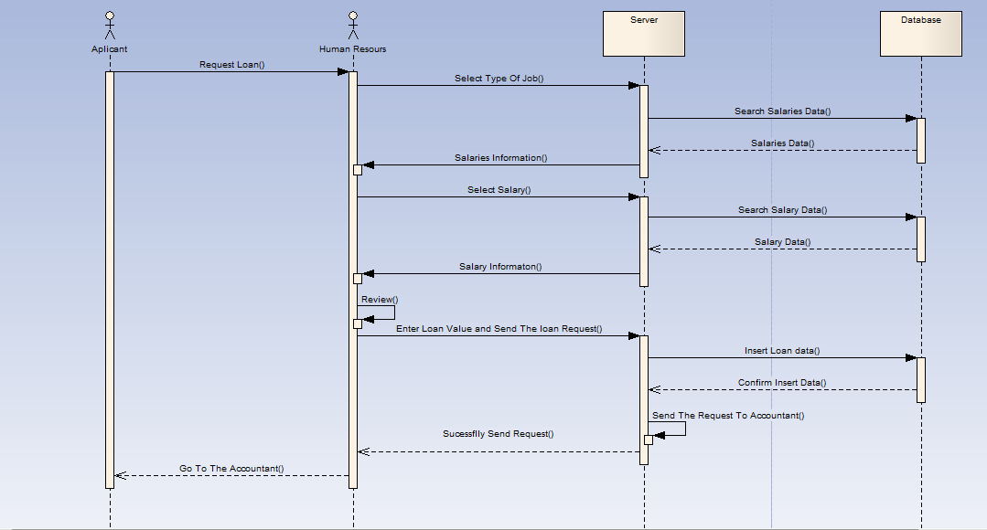

**Salary :**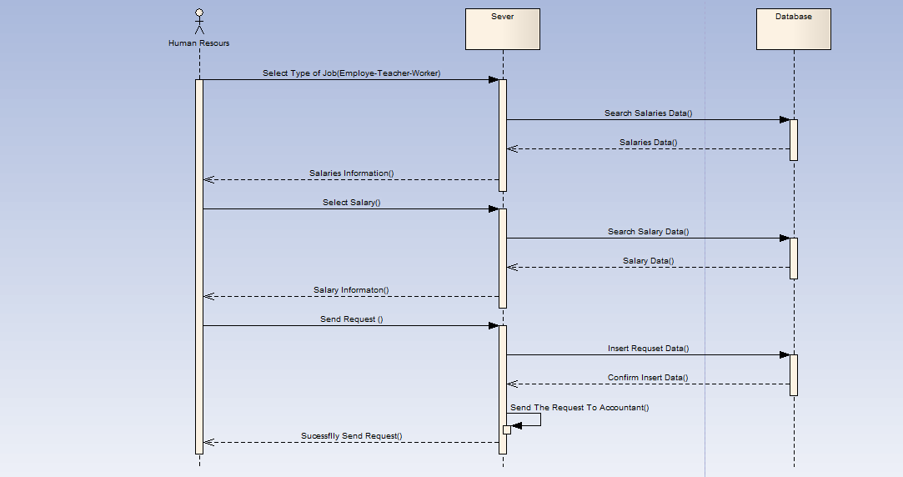

**Accountant :**

**Confirm request (Expense-loans-mustahqat-salary):**

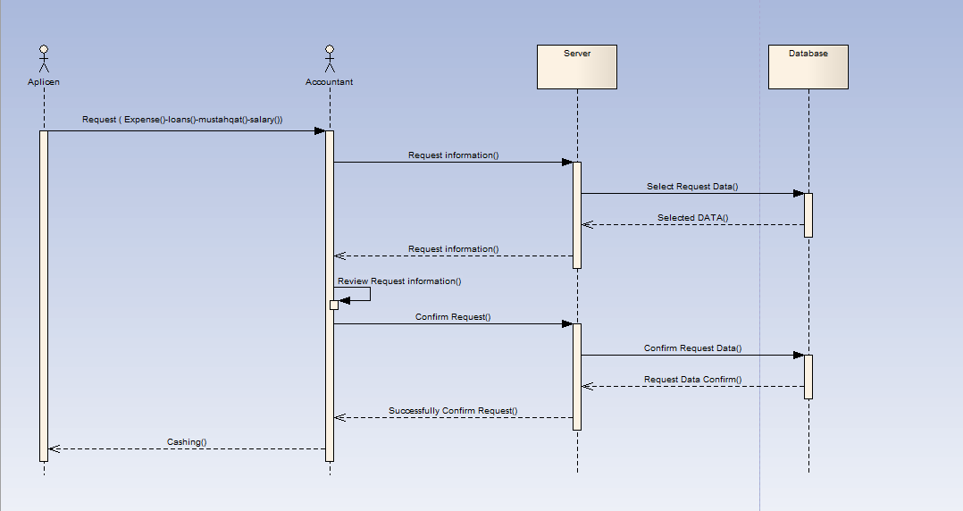

**Feeding Safe :**

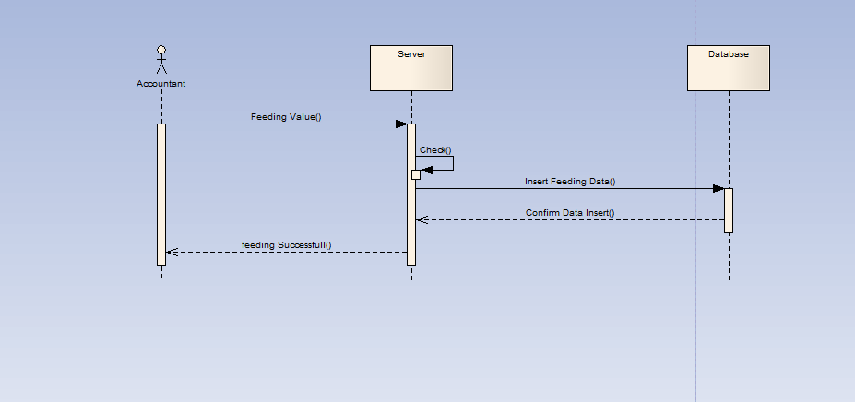

**Register:**

**Add Subject:**

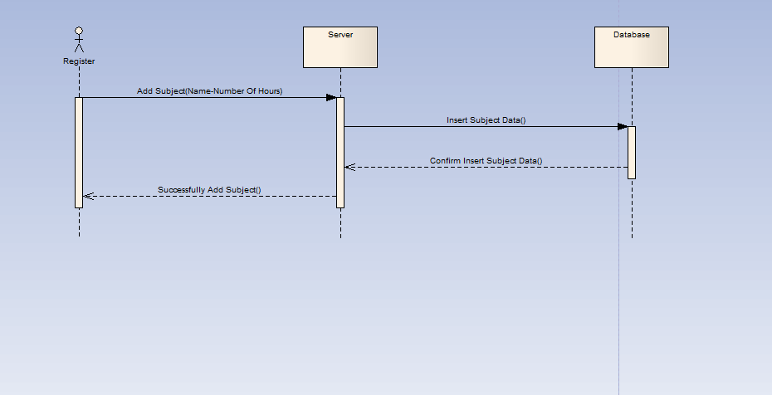

**Fees of Batchs :**

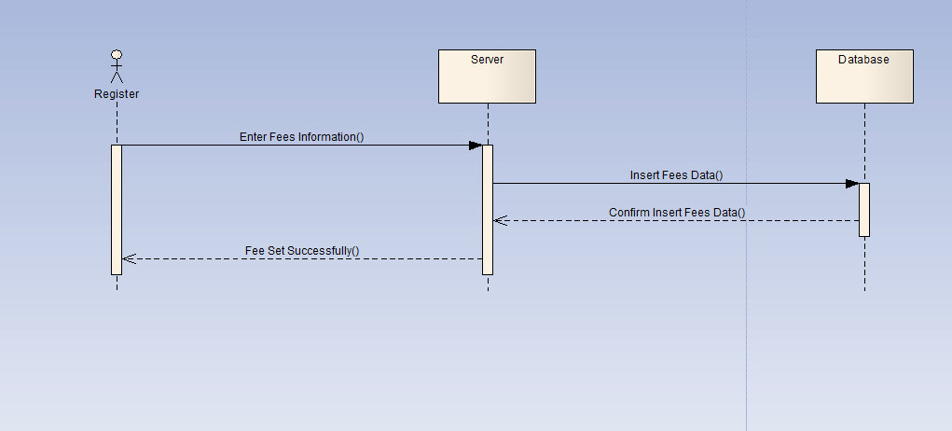

**Subject-Distrbution :**

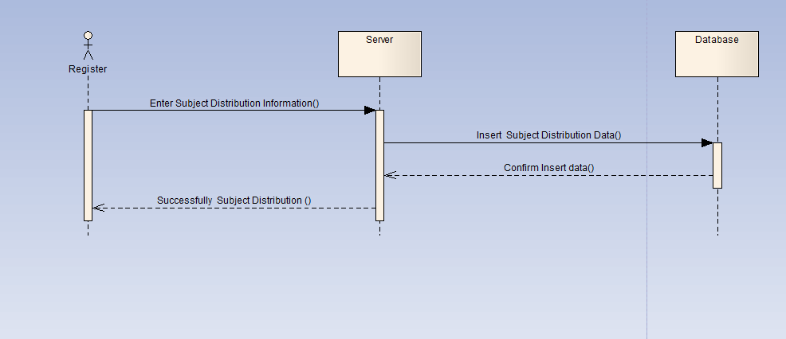

**Teacher Distrebution of Exams:**

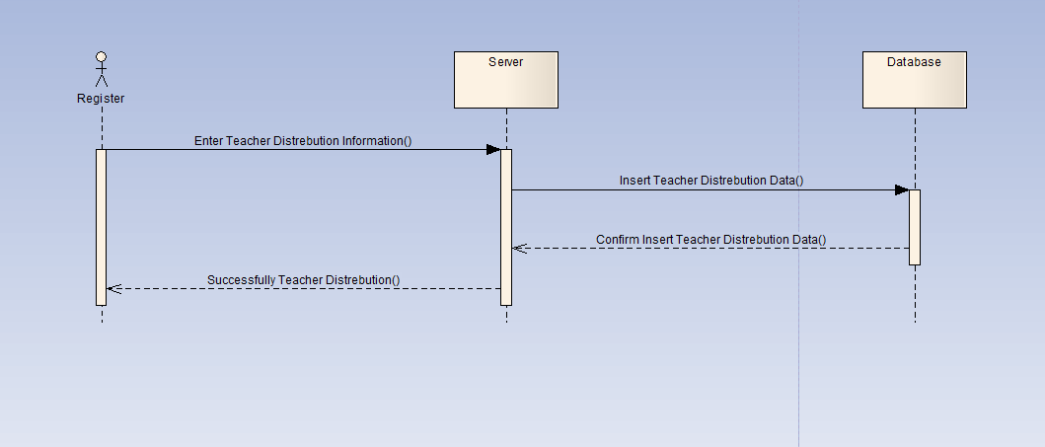

**Medical Examination :**

**Doctor :**

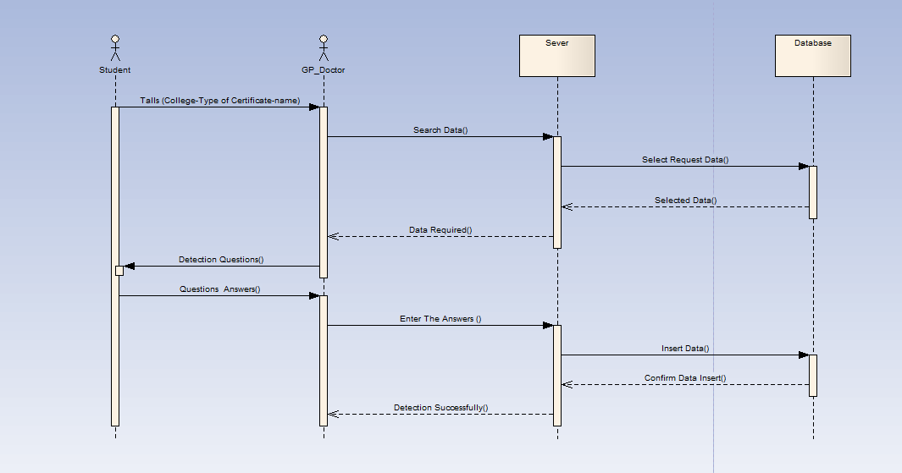

**Optic :**

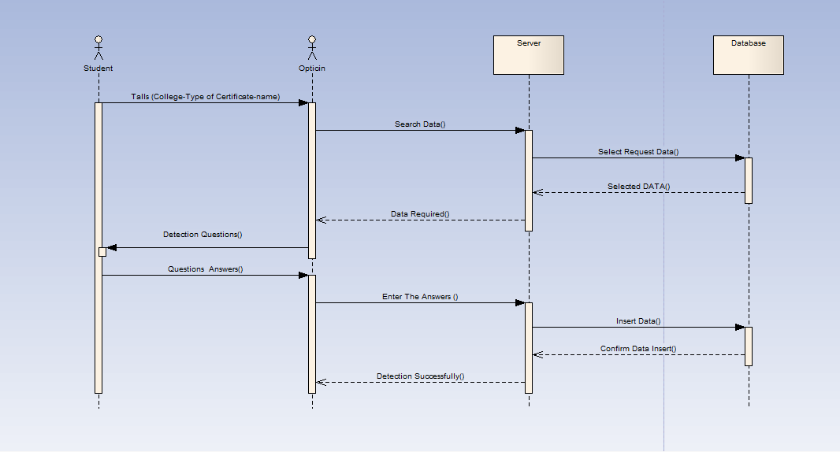

**Psyhiatrist :**

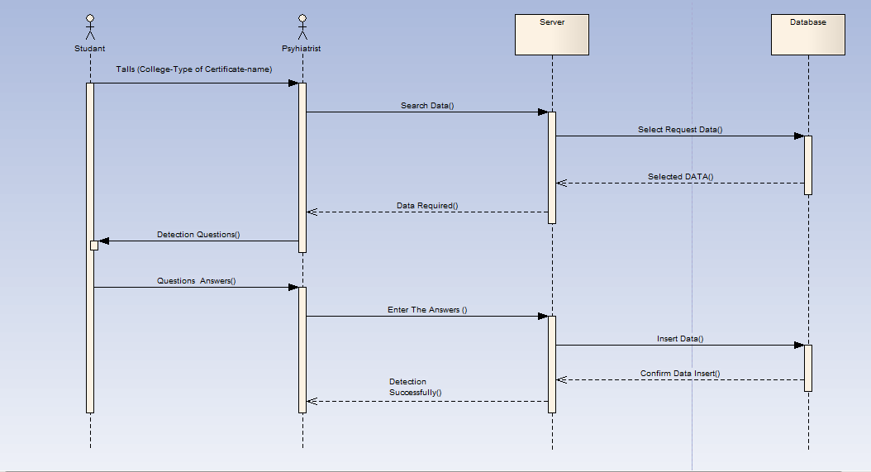

**Scintific Affairs-Admin:**

**Add (Employee-Doctor-Admin):**

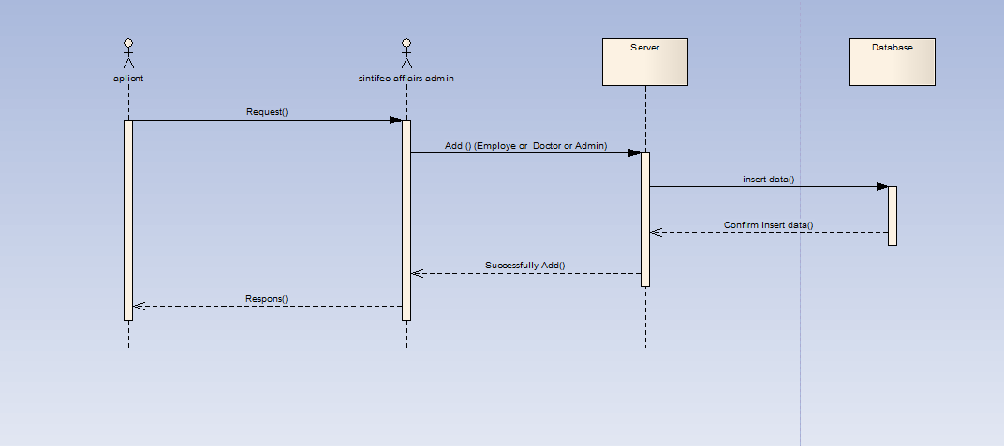

**Scintific Affairs-employee :**

**Rivew -Student-information:**

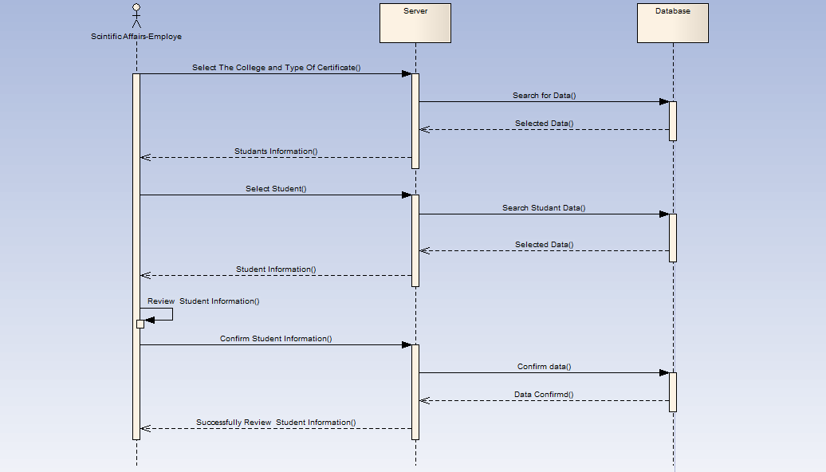

**Student :**

**Result:**

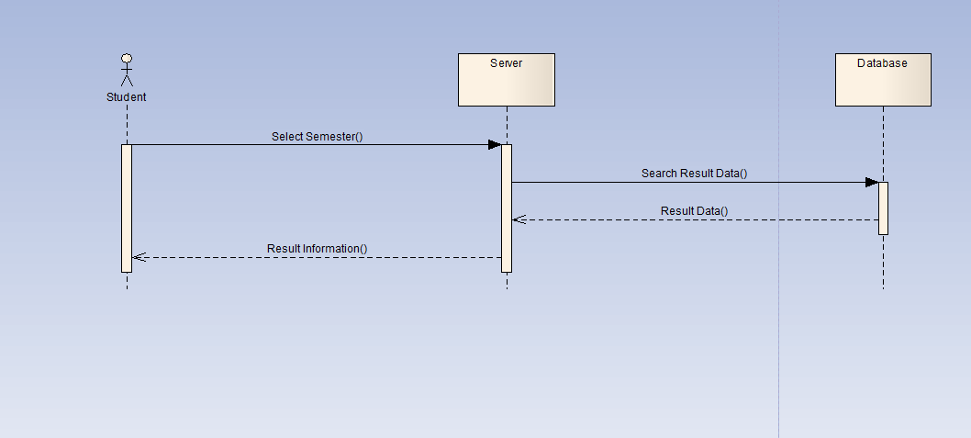

**Online Pay :**

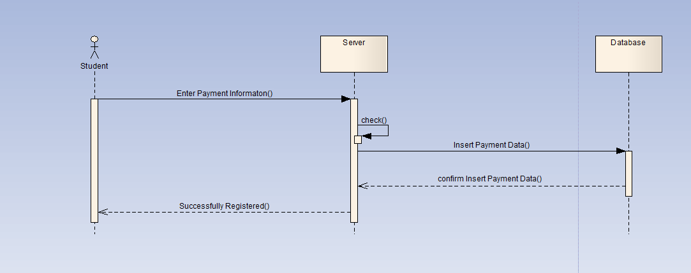

**Login :**

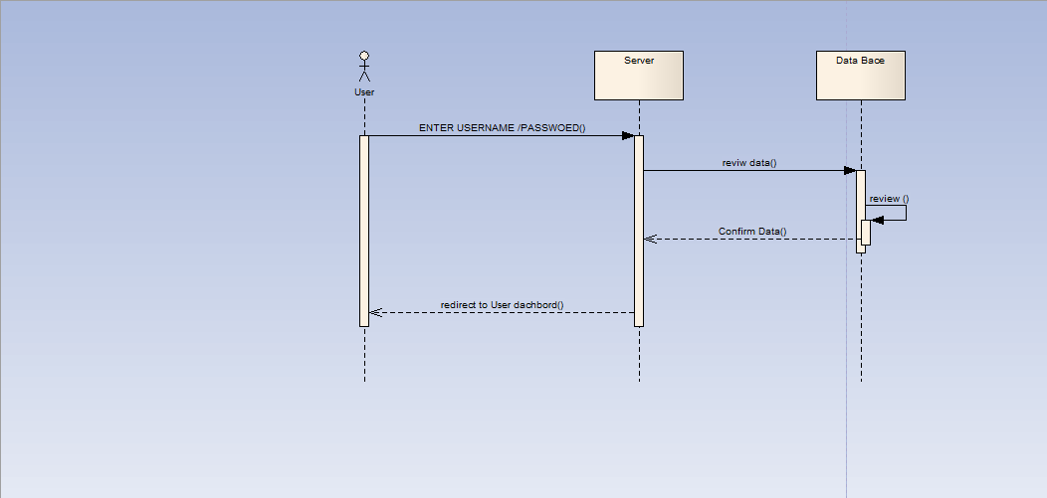

**Change Password :**

